D03 – Simple edition

# Identification data

_G3_ _A_ [https://github.com/ignrodflo/ Acme-Jobs](https://github.com/ignrodflo/Acme-Jobs)  
Group Level GitHub repository   
 (Use a different repository for each deliverable. Make sure that “mary-design-testing” can access it.)

Seville, 20/11/2019  
Place, date



Rafael Liébana Fuentes, Developer   
Student #1: Full name, roles, small picture, and signature

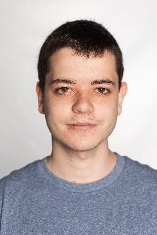

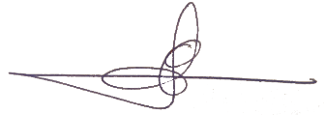Pedro Manuel Cobos Ramos,Analist, Developer   
Student #2: Full name, roles, small picture, and signature

Manuel Sánchez Rodríguez, Developer   
Student #3: Full name, roles, small picture, and signature

Gonzalo Fernandez Jiménez,Deployer, Developer   
Student #4: Full name, roles, small picture, and signature

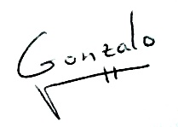



Ignacio José Rodríguez Flores, Project Manager, Developer   
Student #5: Full name, roles, small picture, and signature

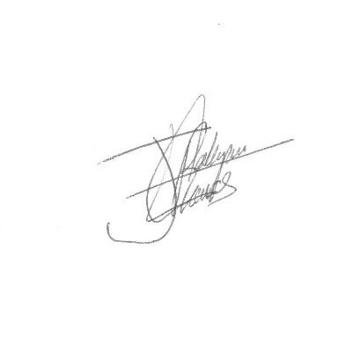

# Responsibility statements

[X] I have taken into account the guidelines provided in the lectures and document “On your deliverables”, which are available at the USE’s e-learning platform.

[X] I understand that I must have a contingency plan and that submitting my deliverable very close to the deadline is likely to result in disaster.

[X] I am an author of this deliverable. I have not cheated in any way.

[X] I have collaborated with my partners on producing this deliverable; in other words, neither have I ridden their coattails nor gobbled them up.

[X] I have learnt from working on this deliverable, so that I can pass my control check.

[X] I understand that my deliverable will be considered failed if I fail to meet any of its requirements, if I fail to submit it by the deadline, or if I do not deliver a filled copy of this form.

# Deliverable

## Item 1: management

* Produce a “README.docx” file in which you report on the following topics (please, note that this file is expected to be empty in most cases):
  + Incidences regarding your workgroup, if any.
  + Interpretations regarding the requirements, if any.
  + Corrections made to the features in the previous deliverables, if any.
* Produce a “Role-Assignment.docx” file in which you provide a recent photo, the full name, the corporate email account, the role played, and the tasks assigned to every member of your workgroup according to their roles.

## Item 2: project

* Produce an Eclipse/Maven project that satisfies the requirements in this deliverable at the desired level. It must include an updated version of file “model.uxf”.

## Item 3: deployment

* Produce the deployment artefacts of your project.
* If applicable: produce a “CREDENTIALS.TXT” document in which you provide the URL and the credentials required to have access to your CleverCloud deployment. Please, recall that every deliverable must result in a different deployment since they are evaluated independently from each other.

# Requirements

## Level C

### Information requirements

Intentionally blank.

### Functional requirements

* A provider principal must be able to:
  + Create new requests.
* A consumer principal must be able to:
  + Create new offers.
* An administrator principal must be able to:
  + Create, update, or delete the announcements in the system.
  + Create, update, or delete the company records in the system.
  + Create, update, or delete the investor records in the system.
  + Create, update, or delete the challenges in the system.

### Non-functional requirements

* Since requests and offers cannot be updated or deleted, it is strongly advised that the corresponding creation forms should include a checkbox to confirm the creation.
* The tickers are not requested to be generated automatically, but entered by the corresponding principals.
* The create/update moments must be generated automatically by the system, where appropriate. They cannot be modified manually.
* The system will support customers in the Euro zone only, so it is requested to handle Euros only; other currencies must be rejected.

## Level B

### Information requirements

Intentionally blank.

### Functional requirements

* An administrator principal must be able to:
  + Update the customisation parameters of the system.

### Non-functional requirements

Intentionally blank.

## Level A

### Information requirements

Intentionally blank.

### Functional requirements

* An administrator principal must be able to:
  + Create, update, and delete the banners in the system.

### Non-functional requirements

* The system must be deployed to CleverCloud.